# Project proposal

# Table of content

1 Project Goal

2 project Objectives

3 project Scope

1. Project in scope
2. Target language Platform
3. Target Audience
4. Out of scope

4 project Deliverable

1. Analysis Document
2. Design Document
3. User Document
4. Quality Plan
5. Project Executive

5 Resources

6 Project Milestone

7 Project Schedule

# Student Details

Name: Tejinder Singh

Student ID:3153177

Submitted To: vision college Auckland (east Tamaki campus)

Tutor name: Jatinder Singh

Level: 6

Course: diploma in software development and design

## PROJECT PROPOSAL

# INTRO TO PROJECT AND OVERVIEW

Main aim is to create a website in which we can register new jobs and we can view jobs or edit jobs or delete jobs.

## Project Description

# Project need

. Need the student’s Details.

. Can Update, delete or edit any Data.

. A fully operational website

# Goals and objectives

Goal for this website is to show the jobs that are available for beginners or experienced person.

They can get any information related to jobs for instance: it shows category or department,

Packages and positions that are available.

The website permits following attributes:

. you can view the whole information allied to job

. It gives access to edit, delete or update the information

# Languages used

. c sharp

. MVC framework

. ADO.net

. bootstrap

. My SQL

# TARGET AUDIENCE:

The primary target of website is to show the jobs available in market. In this website you will see every

Type job whether it is from IT, Business management or hotel management. Moreover, basically main target is to target young youth as they are looking for jobs or for the beginners those who are inexperienced.

# Out of scope:

. user profile could be possible to made in which user can make profile like whenever any job is available so they can get notification for job .

# PROJECT DELIVERABLE

### Analysis Document

### Wireframe of

# System interface design

System interface design is a combination of wireframes of all the pages

# 

# DASHBOARD (HOME PAGE)

# ABOUT ME PAGE

# 

# JOBS AVAILABLE PAGE

# xcccbggf

# Admin page

# 

# Contact us page

# User interface Design

user interface design consists of mock-ups of all pages

### About page

This is a about page about on which information given about the person who created this website.

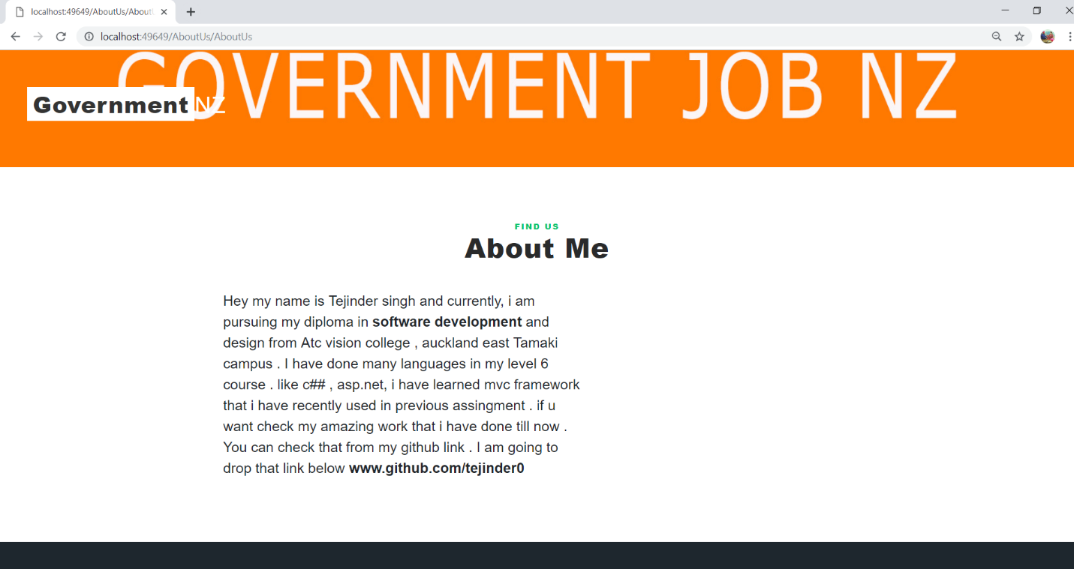

# Admin login

On this page admin can login to make changes like if they want to enter or delete or update

Data. For that u need to enter correct email address or password and then press sign in to

Get enter into admin page.

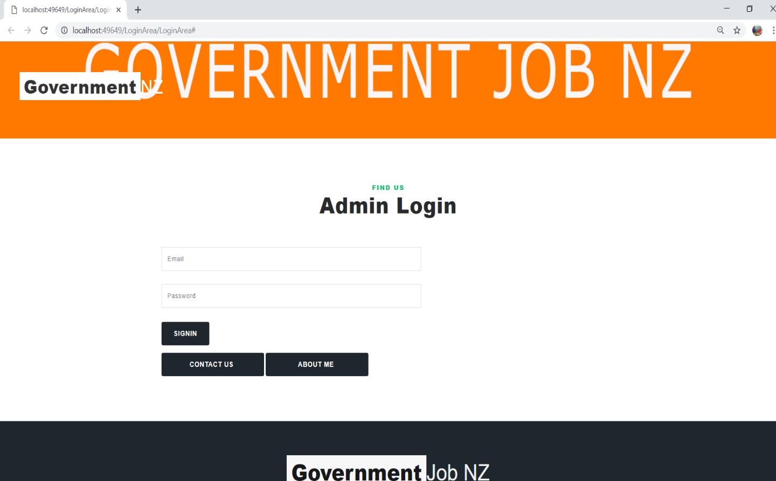

# Job available page

This si the sort of crucial page of website on this you can see the jobs which are obtainable.

You can edit or delete job.

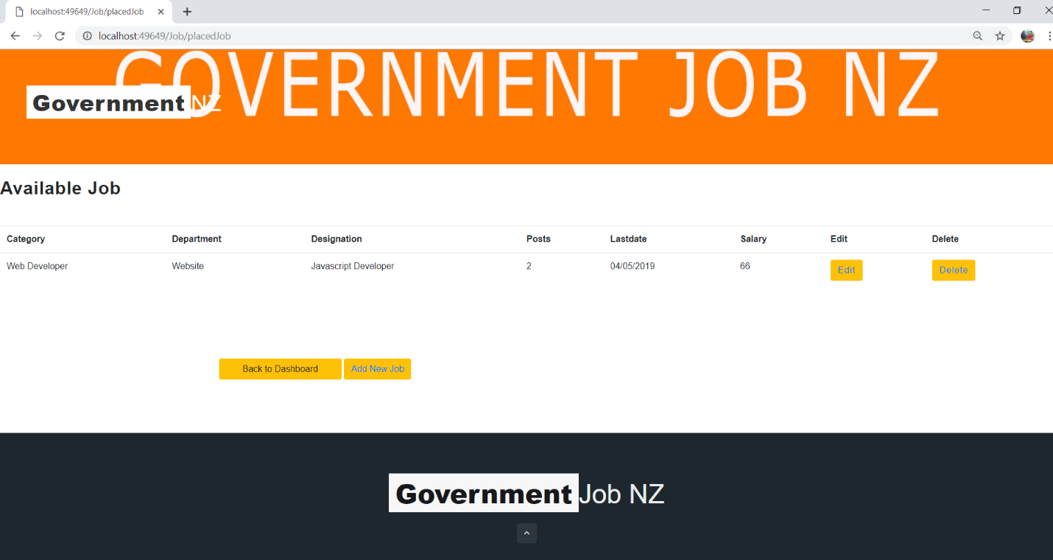

# Contact page

This is contact page from where you can contact admin about any sort of problem. Here is all

Information about contact. So you can contact via Email, phone number and address. Or you can

Just leave a message.

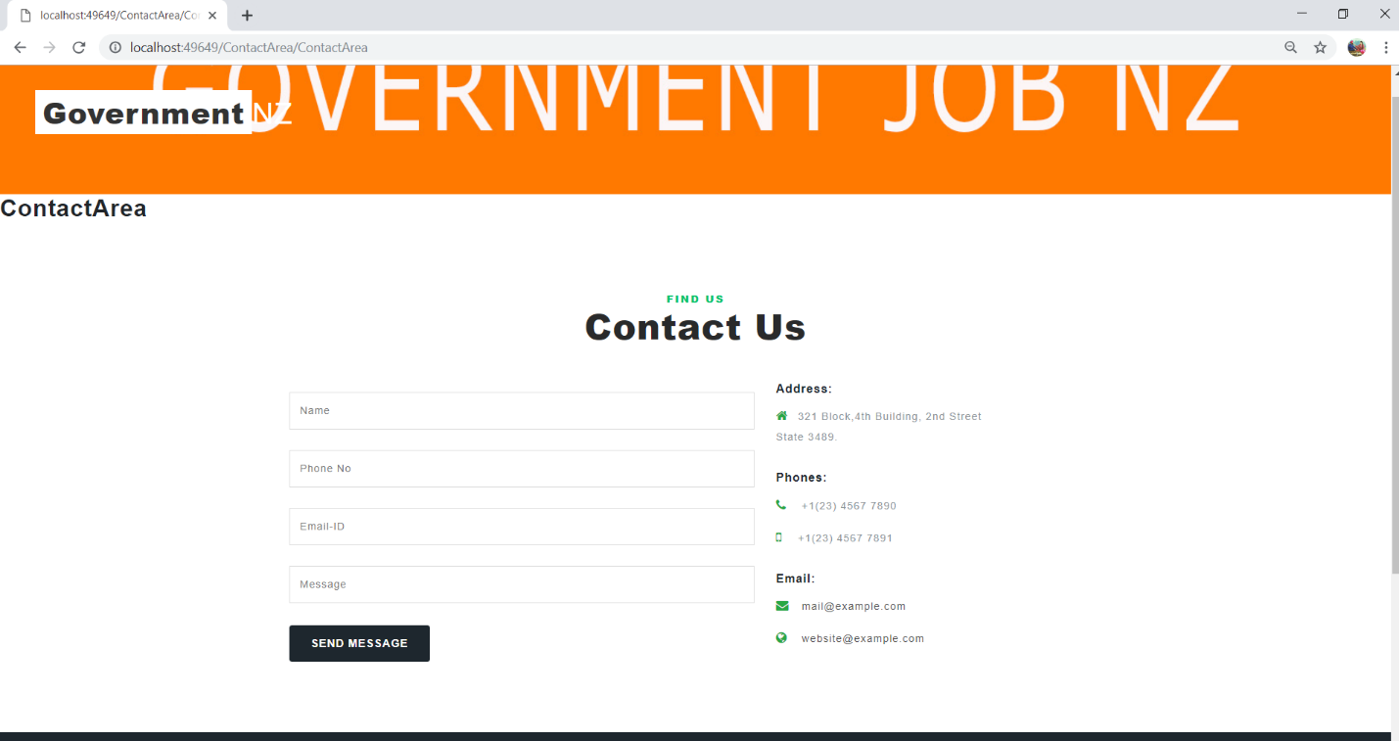

# Dashboard

This is homepage from where you can view jobs that are still available. you just need to click on

Click jobs and you will see list of jobs.

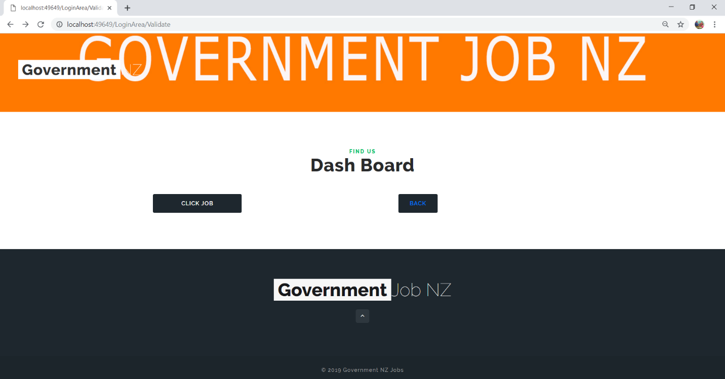

# Create job data page

Here you can create new job which you want to post. you have to fill all the boxes that are given bellow. you need fill everything correctly, then it will be post otherwise it would not post your job.

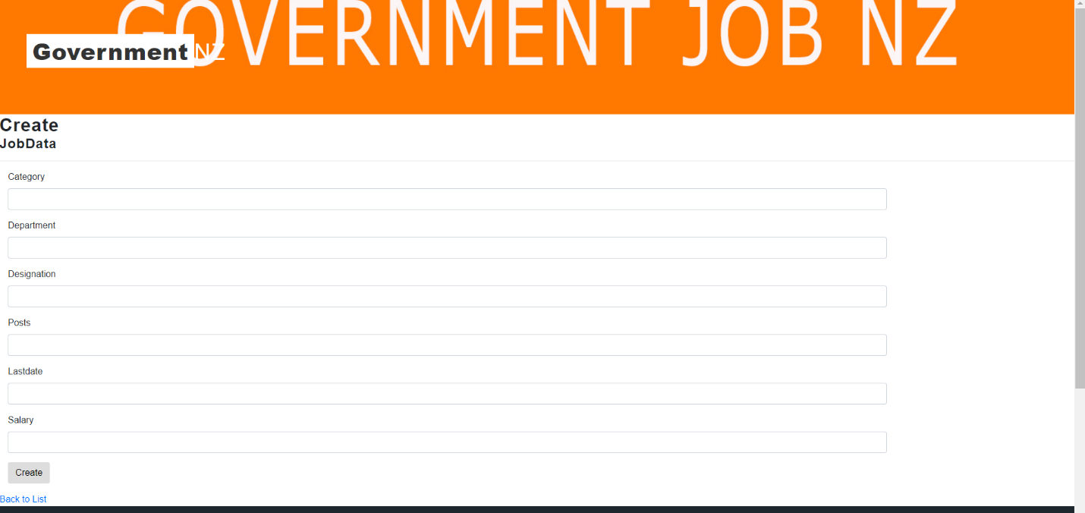

Project milestone:

|  |  |
| --- | --- |
| WORK | HOURS |
| DATABASE | 5 |
| CONTROLLER | 14 |
| FRONT END | 12 |
| BACK END | 23 |
| DOCUMENTATION | 12 |

# Project schedule

|  |  |
| --- | --- |
| WORK | HOURS |
| DATABASE | 10 |
| CONTROLLER | 18 |
| FRONT END | 20 |
| BACK END | 15 |
| DOCUMENTATION | 8 |

# Project Executive summary

### System requirement

. windows 10+

. Intel core processor

. 16 Gb Ram

# Software:

. visual Studio 2017

. Microsoft SQL

# Resources:

Configuration need to complete this project are given bellow:

. system must have 16 of ram.

. PC must be operates latest windows.

. Requires Intel I7 Processor.

. latest Visual Studio 2019 is required for coding.

. SQL server is require to create the database and to make connection between visual studio and coding.

. C#, JQuery, Bootrsrap, HTML, MVC framework, ASP

. mockflow

# Quality Plan

|  |  |  |  |  |  |
| --- | --- | --- | --- | --- | --- |
| Step no. | Test step | Input data | Expecteddata | Actual result | Test result |
| 1 | create job | IT | Job created | As expected | pass |
| 2 | edit job | department | Changes in information | As expected | pass |
| 3 | Update job | salary | Details updated | As expected | pass |
| 4 | Delete job | business | All the details deleted | As expected | pass |

# 